BLU meeting minutes – Jan 26, 2023, 7:30 pm – conference call
Present: Margaret Van Camp, Secty/ Treas., Cindy Cieciwa , assistant Treasurer, Rachel Green, Randy Pritchard, Ruth Hawkins, Duckey Chute, Floya Hawkins.
- New board members welcomed by MVC
- Membership numbers shared by CC. See addendum A.
- Financials shared by CC: 2022 vs 2021 P & L showed net income of 1613.84. Current balance in BLU checking account: $8810.50.
- Discussion and selection of President and VP. After a review of the responsibilities of both positions, MVC called for volunteers. Duckey Chute volunteered for the position of president, and was elected unanimously by the board. Nancy Starkey and Floya Hawkins both volunteered for the position of VP, and NS withdrew after FH volunteered. Floya was elected unanimously by the board.
- MVC asked the board to consider awarding Lifetime Membership status to Lisa Rodenfels, the previous Secty/Treas. After a short discussion, the board voted unanimously to grant the award. Randy volunteered the gift selection services of his wife Rainey to locate an appropriate gift. MVC will be in charge of the accompanying certificate. (Follow up: a BFL statuette was found and purchased on Etsy)
- MVC and NC asked the board to consider again sponsoring the MSWF Herding Dog Demo event in 2023. Several board members noted the high amount of exposure it gives to BFLs and how long Nancy Starkey has been willing to provide the demo. Duckey moved that the past donation amount of $50 be raised to $100, and to reimburse Nancy for the creation and purchase of a re-useable banner to be displayed at the demo calling attention to BLU’s sponsorship (even though Nancy offered to pay for it herself). The motion passed unanimously.
- MVC asked the board to consider an ad in the MSWF catalogue, as it has run before. Approval for the same size ad as 2022 was approved unanimously. MVC will tweak and re-submit the 2022 ad with payment before the Jan 31 deadline. (Follow up: see addendum B)
- The board requested that the BLU trifold brochure be posted to the BLU website for anyone to view, download and distribute at local events. MVC will do so. (Follow up: go to bflsheep .com, scroll down on the landing page – it is posted there).
- MVC requested approval to send out postcards reminding current and recently lapsed members to send in their dues, announce the new board, and request input on the site of the 2024 National show. Approval granted. MVC will send out the mailing within a week. (Follow up: mailed out Feb 1)
- MVC requested board input on updating the website and the possibility of creating a searchable pedigree database that all members may access to research bloodlines. Kelly Cooper, a Canadian member, has volunteered to take on both tasks. The board is very interested and hopes to get the posting of” animals for sale” feature working as well. MVC will follow up with Kelly C. and ask her about the possibility of participating in a future board meeting to both ask and answer questions. (Follow up: email sent to Kelly Feb 4)
- Tabled items: committee chair assignments, goal setting for the BLU.
- Next meeting scheduled for Thursday, February 9, at 7:30 PM Eastern, 6:30 Central, 5:30 Mtn.
- Duckey promised to post her full contact info to the BLU Board FB page (Follow up: complete 1/27/23)
- Youth Conservationist Program is seeking a donor for a BFL yearling ewe for 2023 to be presented at MSWF. In the past, a board member has stepped forward with the donation; thew board has also recently authorized giving a stipend ($300 in the past) to the donor to encourage participation. This will be further discussed at the next meeting. (Follow up: Nancy Starkey has agreed to donate a yearling ewe, and is in contact with the YCP director)
- Adjourn, 9:10 pm Eastern

Addendum A:
BLU registration/ transfer report: 2021 VS 2022

 | 2021 | 2022 | Change
lambs→ | 323 | 394* | +71
older→ | 51 | 49 | -2
transfers→ | 156 | 116** | -40
imported semen→ | 0 | 2 | +2

*includes 2 by non-members
**includes 8 by non-members

BLU membership report: 2021 VS 2022

 | 2021 | 2022 | Change
Renewals→ | 49 | 46 | -3
New members→ | 18 | 15 | -3
Jr members→ | 7 | 9 | +2
Associate members→ | 1 | 1 | None

Addendum B
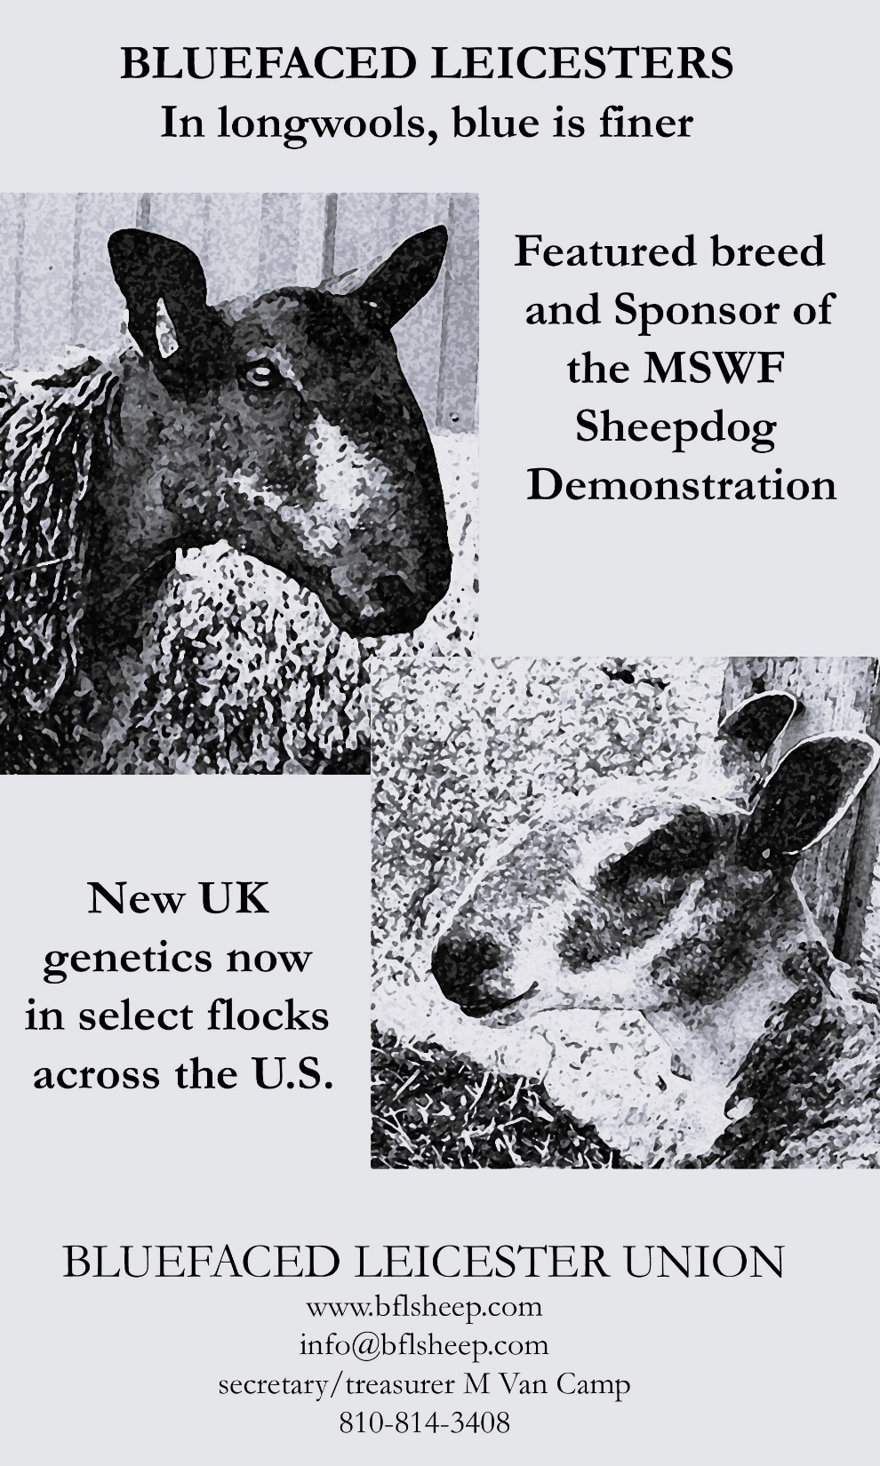
APPROVED – 9 FEB 2023

